INVENTION DISCLOSURE FORM FOR PATENTS

Applicant Name-Marwadi University

- Particulars of Inventors

Mr./Ms/Dr. | Name (Full) | Department | Designation | Mobile No. | Email | Postal Address
Ms | Priyanka Mangi | BTech CE | Assistant Professor | 9484831270 | priyanka.mangi@marwadieducation.edu.in | Marwadi University
Mr | Rushit Trambadia | BTech CE | Student | 7990381601 | trambadiarushit@gmail.com | B903, Copper Stone, Opp Maruti Manor, Sadhu Vaswani Road, Rajkot, 360005
Mr | Vandit Doshi | BTech CE | Student | 9328870424 | vanditdoshi20@gmail.com | 404, SILVER PALACE APP. BEHIND UTSAV HOTEL JUNAGADH ROAD, JETPUR,360370

- Provide title of the invention:
GreenLit Go - Movie Success Prediction Using Data Analytics

- In 100 words or less, please provide an abstract or summary of the invention:
This invention is a machine learning platform that forecasts a movie's box office revenue and financial category before production begins. Unlike academic models artificially inflated by post-release data leakage, our system relies strictly on 46 pre-release signals capturing everything from historical popularity to early trailer engagement. The core predictive engine is an optimized Stacking Ensemble model offering an R² of 0.75, backed by SHAP algorithms to explain every decision transparently. We recently integrated a Generative AI module via Google Gemini that parses raw screenplay PDFs to score narrative viability, making it a complete end-to-end pre-production toolkit.
.
- Detail description of the invention:( Answer to all below are required in detail)
  - Problem the invention is solving
Film financing carries massive risk, yet greenlighting decisions are still largely driven by gut feeling. Existing prediction models fail the industry in three distinct ways. First, academic models frequently "leak" post-release data into training sets—like total theater counts or opening weekend numbers—making them useless for predicting revenue before a film is actually distributed. Second, commercial tools are incredibly expensive closed boxes that refuse to show the reasoning behind their forecasts. Finally, it's notoriously difficult to predict performance across culturally and economically different markets (like Hollywood versus Tollywood) within a single pipeline because historical data formats are so fragmented and scaled differently.

  - General Utility/application of the invention
The primary application is assessing financial risk during a film's early pre-production phase. Producers, distributors, and indie studios can use this web platform to estimate a project's return on investment before signing checks or starting photography. It functions as an interactive scenario-planner: users can swap out cast members, change the target release month, or adjust the budget to instantly see how the final box office responds. Through our new LLM script analyzer, users can also upload raw screenplays directly to get immediate feedback on plot tone and demographic viability without hiring professional human script readers.

  - Advantages of the invention disclosing about the increased efficiency/efficacy
The system drastically reduces the time and administrative cost associated with early market analysis. By providing a transparent accuracy rate (over 62% categorical accuracy and an R² of 0.7504), users can trust the predictions over mere guesswork. Because our platform natively handles over 2,180 curated movies spanning 5 major cinematic industries, studios don't need separate tools for evaluating regional vs. global projects. Furthermore, using Generative AI to scan scripts bypasses the slow, manual industry script coverage process. The inclusion of SHAP explainability means executives aren't just given a random revenue number—they see the exact math and which specific variables drove the estimate up or down.

  - Best way of using the invention as well as possible variants
The optimal deployment is our current cloud-based dashboard connected to a dual-backend system. A producer logs onto the site, uploads a PDF script, and inputs baseline parameters into the interface. The Node.js backend handles these requests and routes the heavy ML workloads to a Python API. The Python end cleans the data, runs the Stacking Ensemble, computes SHAP values, and sends a visual chart breakdown back to the user's browser. A variant could be an enterprise API endpoint specifically for financing agencies, where they automatically feed massive batches of project pitch decks into our backend to receive quick programmatic risk scores to filter out weak investments instantly.

  - Working of invention along with Drawing, schematics and flow diagrams if required with complete explanations

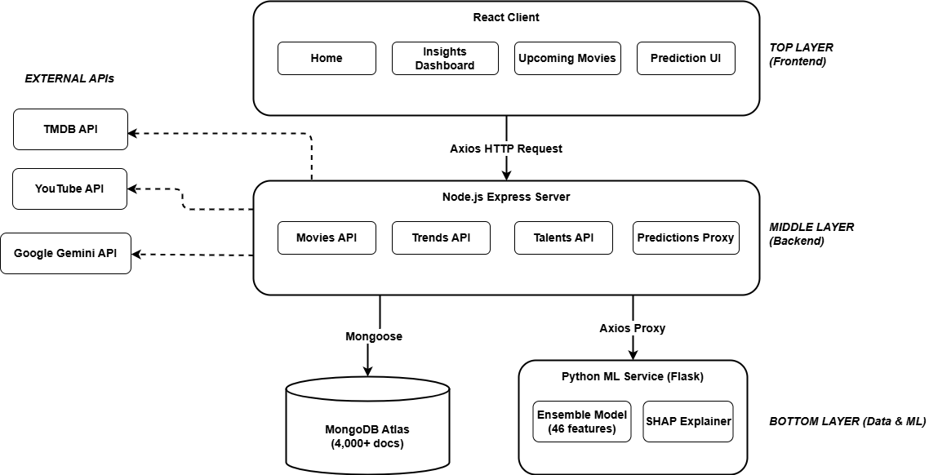

Figure - System Architecture
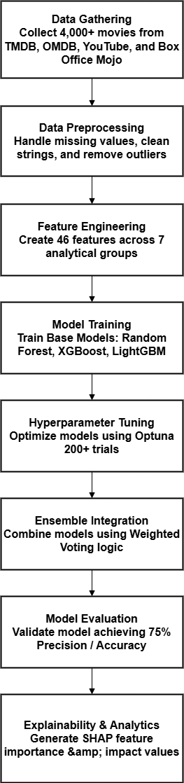
Figure - Workflow Diagram

- Have you conducted Primary Patent Search?
No

- Existing state-of-the-art and prior arts: (Brief background of the existing knowledge/product/process in the market)
Current state-of-the-art platforms, like Cinelytic and Vault AI, offer premium content intelligence. However, they remain highly restrictive, closed-source enterprise software focused almost entirely on Western cinema. They act as "black boxes" and actively refuse to show users the feature logic behind their predictions. In academia, recent papers demonstrate high accuracy on public datasets, but they almost always suffer from data leakage. They accidentally train their algorithms using metrics that don't exist in pre-production (like critic reviews or theater counts), rendering their models unusable for actual forward-looking forecasting. Prior arts consistently fail to combine strict "zero-leakage" data pipelines, explainable ML (SHAP), and Generative AI script parsing inside a truly accessible web application.

- List out the known ways about how others have tried to solve the same or similar problems? Indicate the disadvantages of these approaches. In addition, please identify any prior art documentation or other material that explains or provides examples of such prior art efforts.

S. No. | Existing state of art | Drawbacks in existing state of art | Overcome (how your invention is overcoming the drawback)
1 | Commercial Enterprise Platforms (e.g., Cinelytic, Vault AI) | These platforms operate as proprietary "black boxes," offering predictions without explaining the underlying reasoning. They are prohibitively expensive and almost exclusively focused on the Hollywood ecosystem. | Our system integrates SHAP (SHapley Additive exPlanations) to provide transparent feature attribution for every prediction. It is also trained across 5 distinct film industries (including major Indian cinema markets) rather than just Hollywood.
2 | Script-Analyzing AI (e.g., ScriptBook) | These systems rely purely on Natural Language Processing of screenplays. They demand a finalized script and completely ignore dynamic market data, such as trailer reception and external marketing buzz. | Our invention utilizes a multi-source data pipeline (TMDB, OMDB, YouTube API) to capture pre-release market signals, such as trailer virality and talent popularity scores, which significantly influence actual revenue.
3 | Academic ML Models (e.g., Udandarao & Gupta, 2024; various IEEE/arXiv papers) | Suffer heavily from data leakage by mistakenly including post-release data in training sets, artificially inflating accuracy scores that fail in reality. | We engineered a strict zero-leakage pipeline using 2,180 curated movies. The model relies purely on 46 engineered signals strictly known before a film goes to theaters.

- List the Technical features and Elements of the invention along with the Description of your invention from start to end.
Technical Features & Elements:
- Data Pipeline: Custom scripts to aggregate data from TMDB, OMDB, and YouTube to capture moving metadata and marketing engagement.
- Leakage-Aware Engine: A module that transforms raw data into 46 distinct pre-release markers (e.g., trailer engagement ratios, cast demographic popularity aggregations, and inflation adjustments).
- Stacking Ensemble Core: A multi-layered machine learning architecture utilizing Random Forest, XGBoost, LightGBM, and KNN at the base layer, fed into a RidgeCV meta-learner.
- Generative AI Module: A Node.js integration using the Google Gemini 2.5 Flash API to parse native PDF screenplays for comprehensive narrative metrics.
- Explainability Layer: A SHAP TreeExplainer integration tracking the marginal contribution of each variable.
- Interactive React Frontend: A dashboard built with Vite and ApexCharts allowing real-time scenario simulation.

End-to-End Description: The user submits a PDF screenplay to the web frontend. The Node.js server parses the text, queries the Gemini API, and extracts tonal metrics. The user then inputs production constraints, like the target budget and release timing. This data is routed to the Python ML microservice, which cleans and normalizes the input into exactly 46 features. This data passes through the base ML models and into the RidgeCV meta-learner, producing a final box office revenue estimate alongside a profitability classification. The SHAP library calculates the mathematical reasoning behind the result. The server then bundles the LLM script insights, the ML revenue prediction, and the SHAP data into a JSON package, giving the user an interactive evaluation of their movie.

- List out the features of your invention which are believed to be new and distinguish them over the closest technology.
- Zero-Leakage Architecture: Strict curation of exactly 46 pre-release signals to build a model that genuinely works for real pre-production testing, actively avoiding the flawed datasets utilized by many academic peers.
- Unified Cross-Industry Normalization: Natively handling the financial and popularity scaling differences between Hollywood and various Indian cinema industries (Bollywood, Tollywood) within a single mathematical model.
- Transparent Explainability: Refusing the black-box approach by actively tying the predictive ensemble to a SHAP interpretation layer directly on the user's GUI.
- Dual-Domain Analysis: Combining traditional numerical machine learning (for statistical financial modeling) directly alongside Generative AI (for unstructured PDF screenplay analysis) in one unified workflow.

- Has the invention been built or tested or implemented? If yes please provide the Efficiency/Efficacy Yes, it is fully built and deployed locally. Our final Stacking Ensemble model was trained and validated on a hand-curated dataset of 2,180 films. Testing indicates that it achieves an R² score of 0.7504 for revenue prediction and an overall classification accuracy of 62.39% across five distinct box office profit outcomes. This establishes a highly reliable baseline for capturing ticket sales variance without accidentally leaking future data into the system. The underlying microservice architecture smoothly coordinates the slower, high-latency LLM API calls with the rapid-inference ML algorithms to ensure the user gets a response in seconds.

- Briefly state when and how you first conceived this idea?
The core idea emerged while researching the immense financial friction independent filmmakers face when formulating distribution strategies. We noticed that top-tier studios purchase proprietary software to minimize their risk down to a science, while smaller creators are forced to operate on hope and guesswork. The actual technical architecture was conceived when we realized that analyzing a movie based solely on its script or solely on its metadata wasn't enough. We needed to fuse modern LLMs (to evaluate the screenplay) with a robust stacking ensemble (to evaluate early marketing buzz and historical data). Connecting those two different domains became the entire basis of the project.

- Have you sold, offered for sale, publicly used or published anything related to this invention? If yes, please briefly explain the dates and circumstances. List those individuals to whom you have revealed your invention. Were non-discloser documents signed prior to discloser in each case? Please state any deadlines of which you may be aware for filing an application on this invention.
No. The invention has not been sold, offered for sale, or formally published in any public journal. It has only been discussed internally among the project team and designated faculty advisors at our university for academic evaluation purposes. No external non-disclosure agreements have been executed because the work has remained localized to our internal academic environment. We are not currently aware of any immediate statutory deadlines for filing, other than the desire to secure protection prior to any future public exhibition or deployment.

- Include any reasons that your invention would not have been obvious to someone of average skill in the art.
To a typical data scientist, standard practice is to simply throw generic neural networks at huge datasets to predict financial behavior. Our methodology is non-obvious because we actively reject deep learning in favor of a specialized, Optuna-tuned Stacking Ensemble stacked with specific tree-based models and KNN. We did this deliberately because neural networks act as black boxes, whereas our tree-stack preserves SHAP explainability. Additionally, building a unified model that properly normalizes the massive economic differences between a $200 million global Hollywood blockbuster and a modestly budgeted regional hit required non-obvious baseline scaling calculations. Finally, merging qualitative AI outputs (reading a script) and strict quantitative predictions (projecting revenue) seamlessly in a single pipeline is rarely attempted in traditional media modeling.

- Additional comments by inventor (if you want to give more details out of scope of this IDF).
None at this time

- Drawings/Flowchart/Table
Please refer to the attached System Architecture Diagram and Machine Learning Pipeline Schematic.

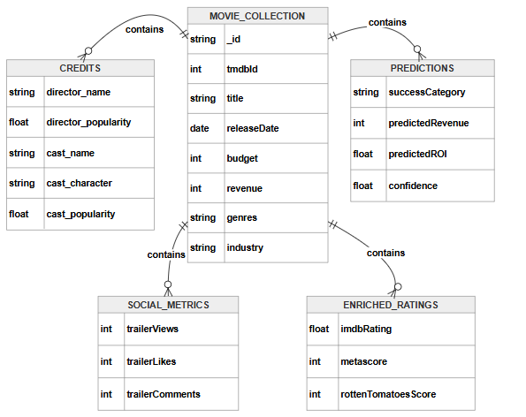
Figure - Physical ER Diagram

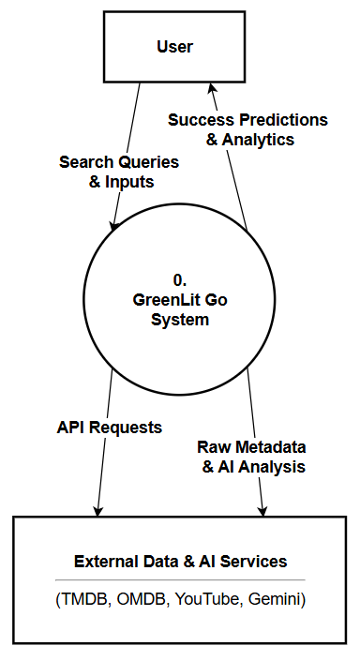
Figure - DFD Diagram Level 1

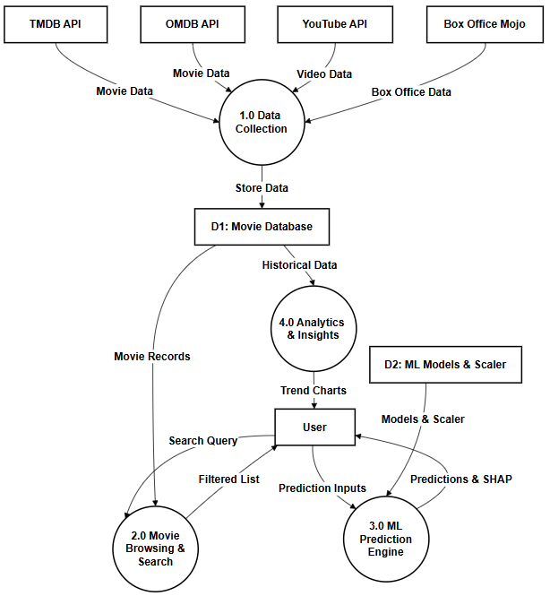
Figure - DFD Diagram Level 1

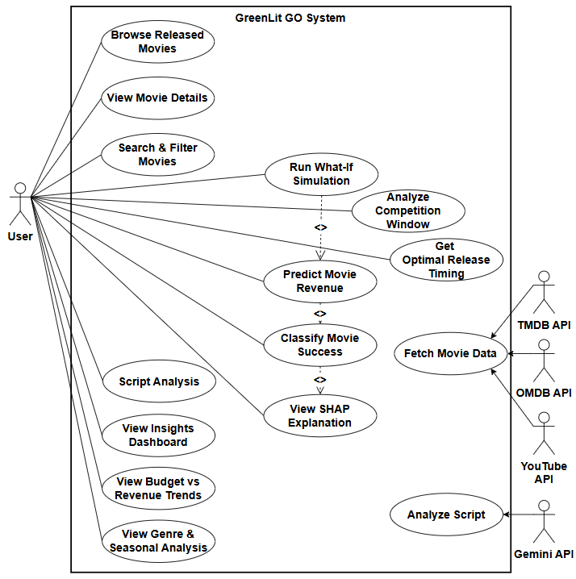
Figure - Use Case Diagram
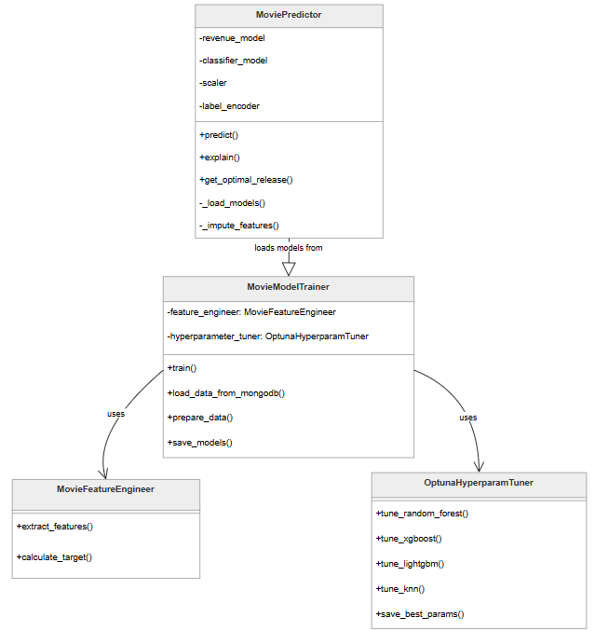
Figure - Class Diagram

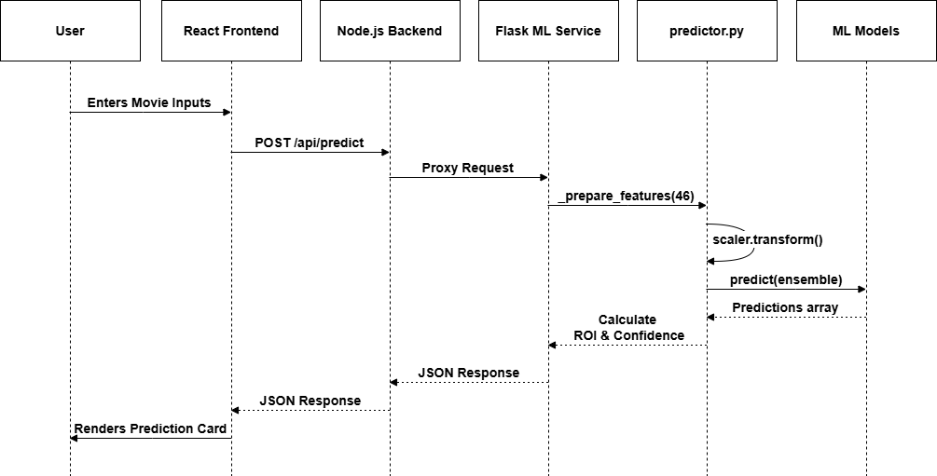
Figure - Sequence Diagram
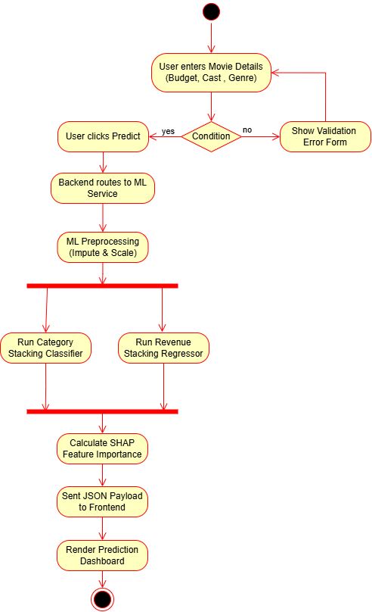
Figure - Activity Diagram

